VLSI LAB FILE

INDERPREET SINGH

2023UEC2691

DEPARTMENT OF ELECTRONICS AND COMMUNICATION ENGINEERING
INDEX:
- V-I Characteristics of N-channel MOSFET.
- Finding Noise margin and Time Delay of an Inverter
- Transient and Frequency Response of a CS Amplifier
- Create a Full adder using MOS transistors and perform transient analysis.

EXPERIMENT-1
Aim: To plot the V-I Characteristics of a N-Channel MOSFET

Theory: In electronics, the metal–oxide–semiconductor field-effect transistor is a type of field-effect transistor , most commonly fabricated by the controlled oxidation of silicon. It has an insulated gate, the voltage of which determines the conductivity of the device.

The voltage applied on the gate of a MOSFET controls the flow of current from the drain to source terminals (in a nmos).
If the voltage applied to the gate is under a certain threshold voltage , no current is conducted between the drain and source terminals and the device is said to be in cut-off.

I.E If, V_{gs} < V_{th}
=> I_{D} = 0

If enough voltage is applied to the gate of the NMOSFET , that will repel any holes in the p-type substrate between the two n-type wells and attract electrons towards it , creating an inversion layer which acts as a channel between the two highly doped n type wells.
The gate and channel region form a parallel plate capacitor, an electric field develops in the upward direction which controls the amount of e⁻ in the conductive channel and thus the conductivity of the channel.

As V_{gs} is increased the voltage across the channel changes thus creating a flow of electrons through it given by.

I_{D} = $\frac{1}{2}$k_{n}$\frac{W}{L}$[ 2(V_{gs} - V_{th})V_{ds} – V_{ds}² ]

where k_{n} is called the process transconductance parameter and is given by

k_{n} = µ_{n}C_{ox}
where μ_{n} is the mobility of electrons is C_{ox} is the oxide capacitance.

This equation holds for as long as V_{ds} < V_{ov} ,when V_{ds} > V_{ov} the channel depth at the drain becomes almost zero and gives rise to channel pinch-off. Increasing V_{ds} has no effect of the value of the drain current if channel effects are ignored.
I_{D} = $\frac{1}{2}$k_{n}$\frac{W}{L}V^{2}$_{ov}
where V_{ov} = V_{gs} - V_{th}
This is an idealization based on the assumption that once V_{ds} = V_{ov} then increasing V_{ds} any further has no effect on the shape of the channel.
In reality , as V_{ds} is increased the point of channel pinch of moves slightly away from the drain and towards the source.
The voltage drop across the channel remains V_{ov} and the additional voltage is dropped across the narrow depletion region between the drain and the point of pinch off.
The modified expression for I_{D} is given by:
I_{D} = $\frac{1}{2}$k_{n}$\frac{W}{L}V^{2}$_{ov}(1+λV_{ds})
Circuits:
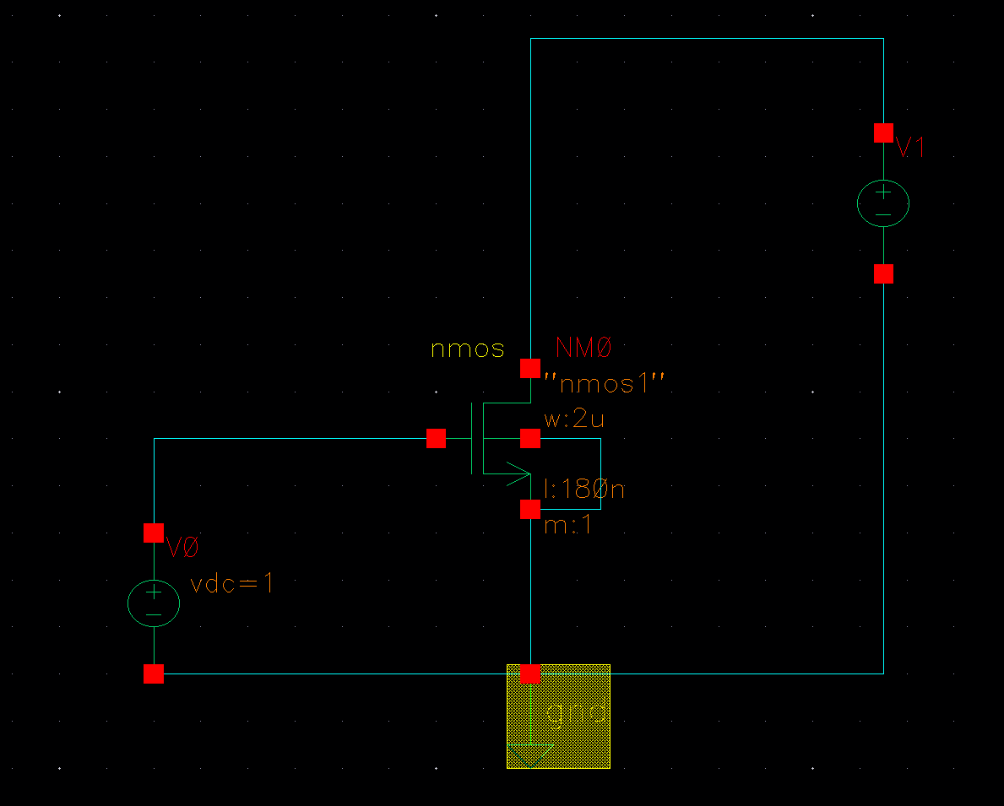

Once V0 is varied while V1 is held constant and Once V1 is varied when V0 is held constant.
The resulting V-I characteristics of the device are
Results: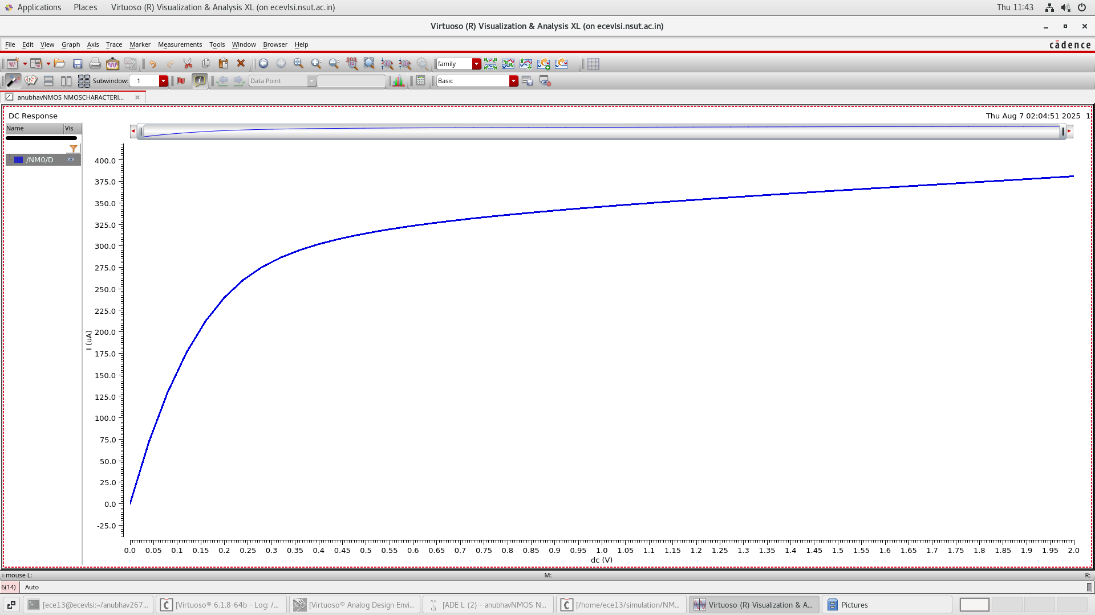
I_{D} vs V_{ds}
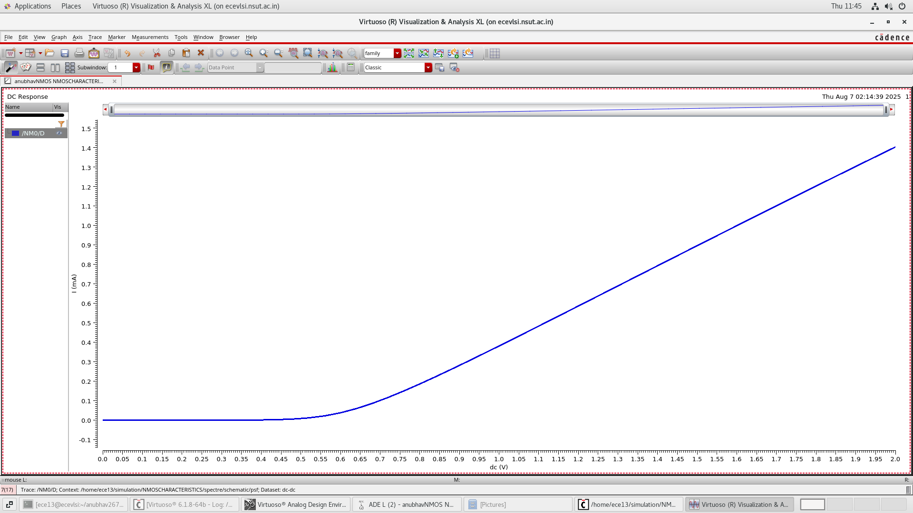
I_{D} vs V_{gs}
EXPERIMENT 2:
Aim: To find the Noise Margin and time delay of a CMOS Inverter using DC and transient analysis.
Theory: A CMOS inverter is the most fundamental logic gate in digital electronics. It inverts the input signal: when the input is high, the output is low, and vice versa.
A CMOS inverter consists of two transistors:
PMOS (P-type MOSFET) on the top, connected to V_{CC}
NMOS (N-type MOSFET) on the bottom, connected to ground

The gates of both transistors are connected together as the input, and their drains are connected together as the output.
In a CMOS inverter, noise margin is the amount of noise a gate can tolerate on its input without causing an error in its output, defined by the high noise margin (NMH) and low noise margin (NML). These margins are calculated using the CMOS inverter transfer characteristic (VTC) and the key input/output voltage levels: NML is the difference between the low input voltage (VIL) and the low output voltage (VOL), while NMH is the difference between the high output voltage (VOH) and the high input voltage (VIH). A larger noise margin indicates greater robustness to noise.
NM_{H} = V_{OH} – V_{IH}
NM_{L} = V_{IL} - V_{OL}
The propagation delay in a CMOS inverter is the time it takes for the output signal to respond to a change in the input signal, specifically the time it takes for the output voltage to reach 50% of its steady-state value after the input crosses 50% of the supply voltage. It is caused by the time required to charge and discharge the load capacitance (CL) through the PMOS and NMOS transistors, respectively. This delay is a critical factor in determining the maximum operating speed of integrated circuits, as it limits the rate at which signals can propagate through a logic system.

Circuit:
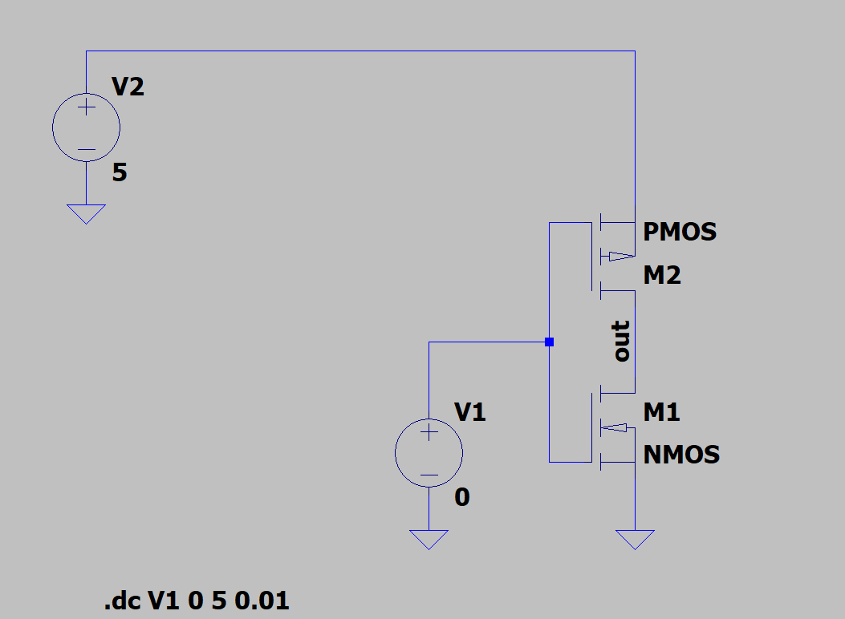
Result:
The VTC of the inverter was
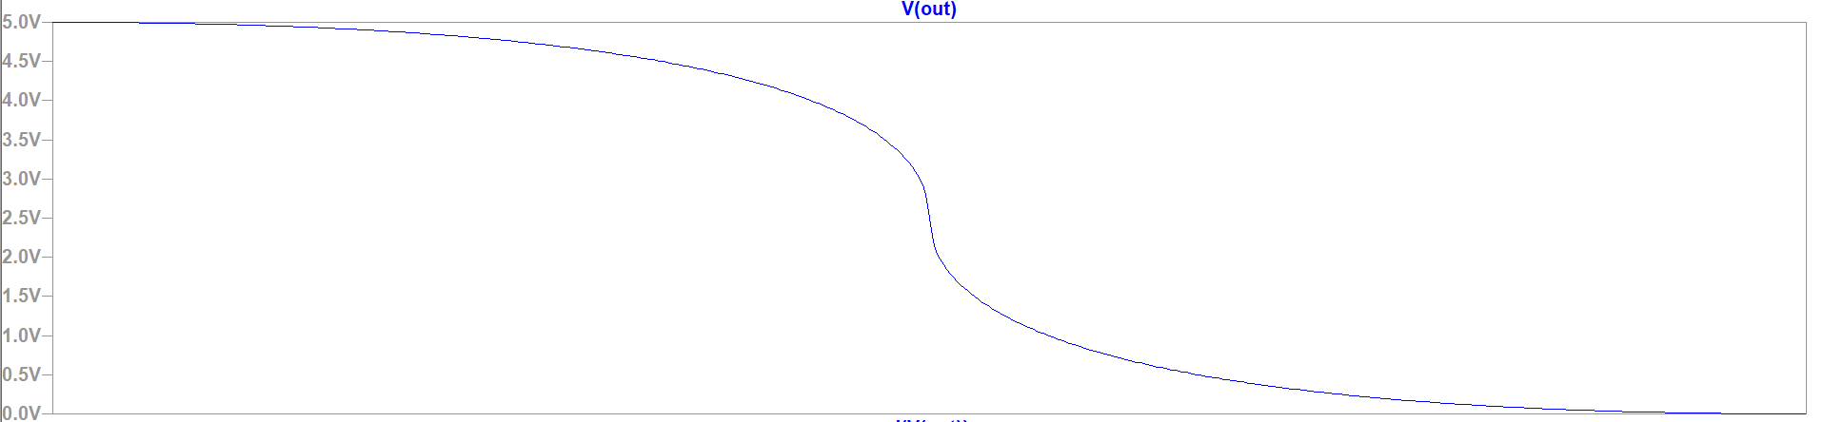
V_{IL} and V_{IH} are calculated at the points where the slope of the VTC is -1.
Here V_{IL} = 1.88V
V_{IO} = 3.12V
So, NM_{H} = 5- 3.12 = 1.88V
And NM_{L} = 1.88 -0 = 1.88V
Inverter propagation delay is the time it takes for the output of a logic inverter to change in response to a change in its input signal, measured at the 50% voltage threshold. This delay is unavoidable in CMOS inverters due to the finite time required to charge and discharge the load capacitance and the inherent switching times of the NMOS and PMOS transistors. Key factors influencing this delay include the size of the transistors, the output load capacitance, the supply voltage, temperature, and the input transition time.
Using the same circuit as shown before but with a rising edge input with rise time 10 nanoseconds:-
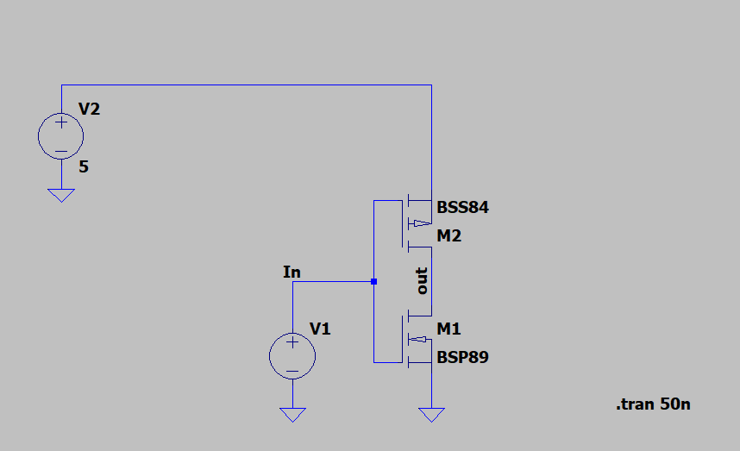
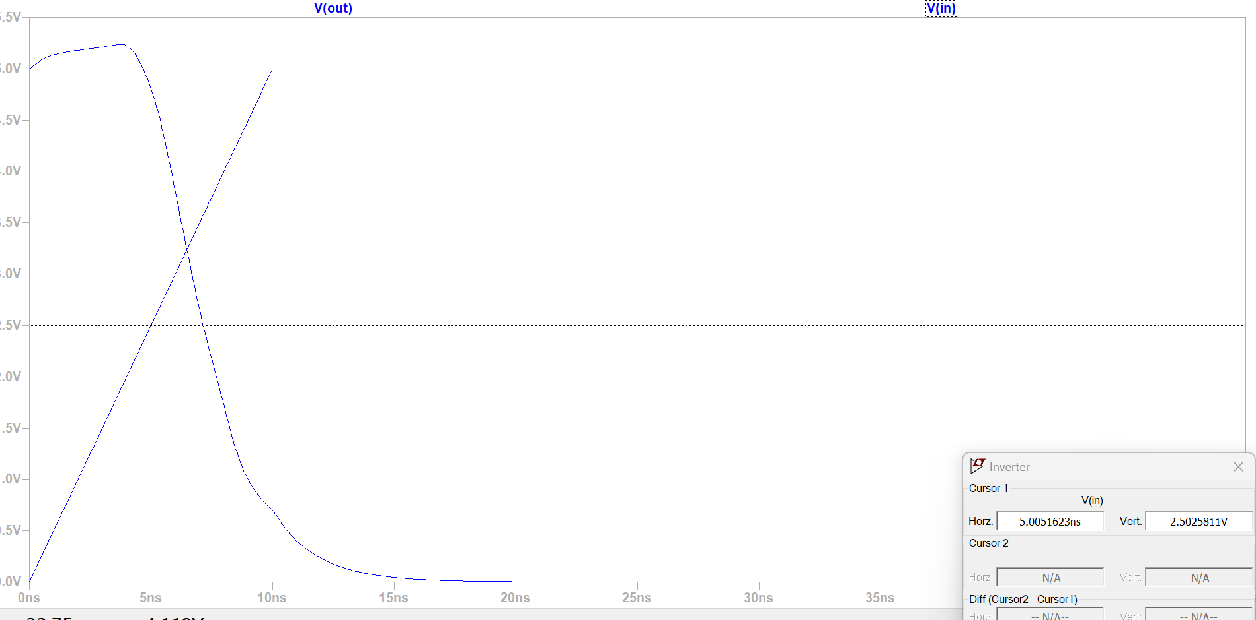
Here T_{Vin50%} = 5.005ns
And T_{Vout50%} = 7.153nsτ
So τ_{PHL} = 7.153ns-5.005ns = 2.148ns
Similarly doing the same for the low to high transition.
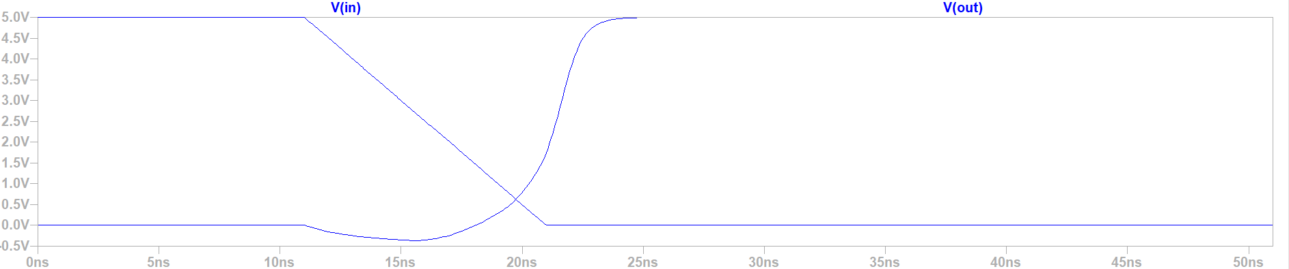
Here T_{Vin50%} = 15.9613ns
And T_{Vout50%} = 21.3756ns
So τ_{PLH} = 21.3756 – 15.9613ns = 5.4143ns
As τ_{prop} = $\frac{ τ_{PHL}+ τ_{PLH}}{2}$ = 3.78115ns
Result:- The Noise margins of the inverter are
NM_{H} = 1.88V
NM_{L} = 1.88V
And the propagation delay is
τ_{prop} = 3.78115ns

EXPERIMENT-3
Aim: To plot the transient and frequency response of Common Source Amplifier
Theory: MOSFETs (Metal-Oxide-Semiconductor Field-Effect Transistors) are widely used in analog electronics for amplifying signals, particularly in audio systems, RF circuits, and analog signal processing. They operate by controlling the current flow between the drain and source terminals based on the voltage applied to the gate.
A NMOS can be treated like voltage controlled current source as in the following model.
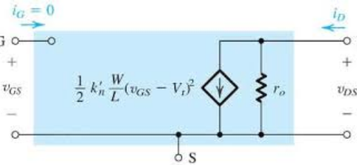
For small perturbations around a quiescent point of the amplifier the drain current is almost linearly related to the gate-source voltage and this gives rise to the small signal model of the NMOS.
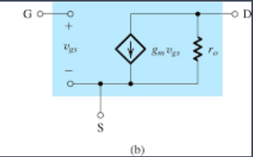
For a Common source amplifier the small signal voltage gain is given by:
A_{v} = g_{m}(R_{D} || R_{o})
where g_{m} is the transconductance of a NMOS given by
g_{m} = $\frac{2I}{V}$ ,
where I = drain current at the Q point
and V = Overdrive voltage at the Q point
Circuit:
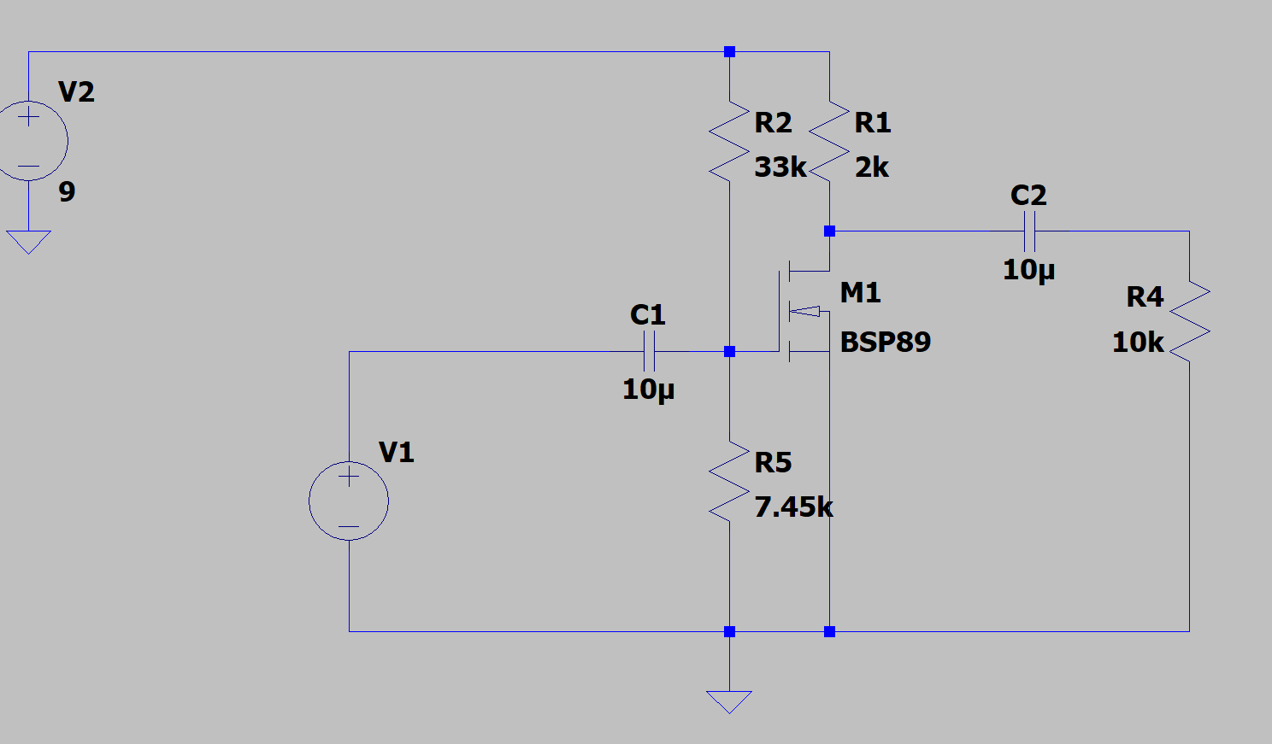

Considering the parasitic capacitances present in the NMOS.
The two poles of the circuit come out to be

ω_{p1} = $\frac{1}{R_{th}\left[C_{π} + C_{\begin{aligned}μ \\ \end{aligned}}\left(1+g_{m}R_{D}\right)\right]}$ and
$ω_{p2}= \frac{1}{R_{L}^{'}\left(C_{μ}+C_{cs}\right)}$

Results:
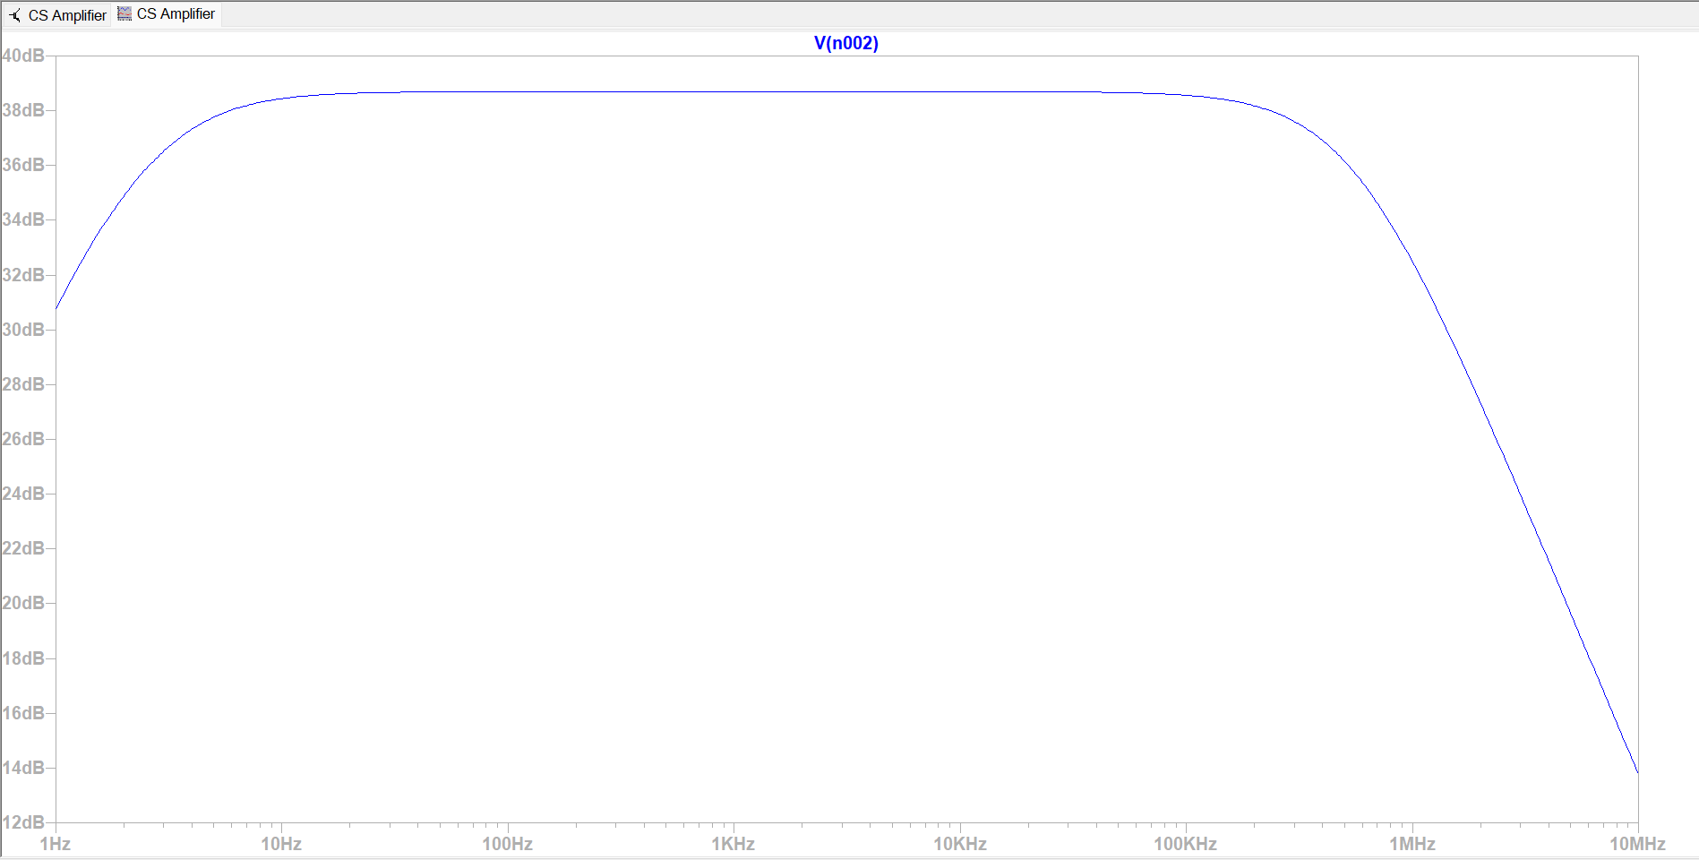
Frequency Response of CS stage
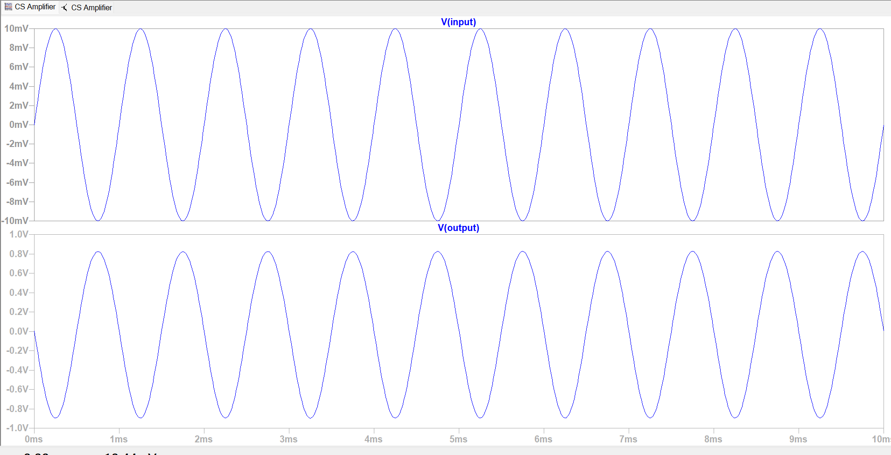
Transient Response when a sine wave is applied to the input.

EXPERIMENT-4
Aim:- To design a full adder using MOS transistors and perform transient analysis.
Theory:- Full Adder is a combinational circuit that adds three inputs and produces two outputs. The first two inputs are A and B and the third input is an input carry as C-IN. The output carry is designated as C-OUT and the normal output is designated as S which is SUM.
The truth table of a full adder is:
A | B | C | COUT | SUM
0 | 0 | 0 | 0 | 0
0 | 0 | 1 | 0 | 1
0 | 1 | 0 | 0 | 1
0 | 1 | 1 | 1 | 0
1 | 0 | 0 | 0 | 1
1 | 0 | 1 | 1 | 0
1 | 1 | 0 | 1 | 0
1 | 1 | 1 | 1 | 1

Solving the Karnaugh Map for Cout and Sum results in the minimized Boolean expressions:
Sum = $A ⊕ B ⊕ C$
Cout = AB + C(A⊕B)
Circuit:
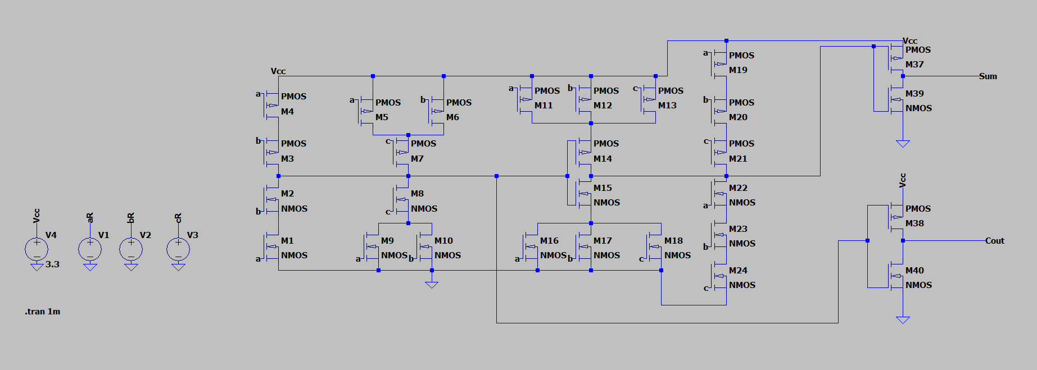
Result: The transient response of the circuit is
